Minimized thermal expansion mismatch of cobalt-based perovskite air electrodes for solid oxide cells
Zhishan Li, ª Meilan Peng,ª Yingru Zhao,ª Jianhui Li ^{b} and Yifei Sun *^{acd}
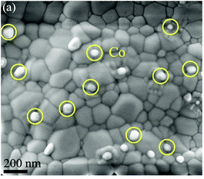
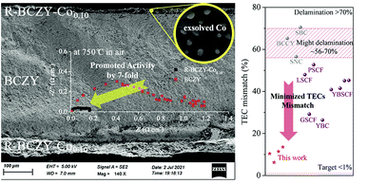

Layered Ag-graphene films synthesized by Gamma ray irradiation for stable lithium metal anodes in carbonate-based electrolytes
Liu, JX (Liu, Jiaxiang) ¹Ma, HS (Ma, Haoshen) ¹Wen, ZP (Wen, Zhipeng) ²Li, HY (Li, Huiyang) ²Yang, J (Yang, Jin) ²Pei, NB (Pei, Nanbiao) ¹Zhang, P (Zhang, Peng) ¹Zhao, JB (Zhao, Jinbao) ^{1, 2}
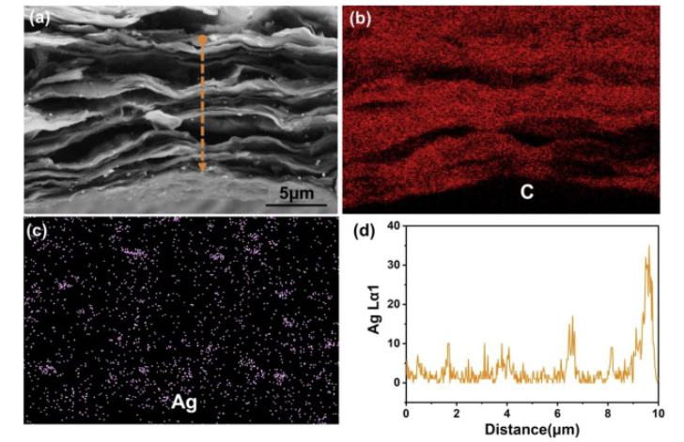

Layered Ag-graphene films synthesized by Gamma ray irradiation for stable lithium metal anodes in carbonate-based electrolytes

Author lisha

